Exploratory Data Analysis
using Python

Project Information
- Title: Exploratory Data Analysis of Housing Dataset
- Name: Krishna S
- DA/DS
- Batch: May - 2025
- Online/Offline: Offline
- Roll Number: 16525CBRE17

Table of Contents
- Introduction
- Aim
- Business Problem / Problem Statement
- Project Workflow
- Data Understanding
- Data Cleaning
- Obtaining Derived Metrics
- Filtering Data for Analysis
- Statistical Analysis
- Exploratory Data Analysis (EDA) - Univariate Analysis
- Bivariate Analysis
- Multivariate Analysis
- Overall Insights from Analysis
- Conclusion

1. Introduction
This project presents a comprehensive exploratory data analysis of a housing dataset containing 18 key attributes that influence residential property values. The dataset encompasses various dimensions including temporal data, physical property characteristics, quality indicators, and geographical information. Through systematic analysis using Python's data science ecosystem, this study aims to uncover hidden patterns, relationships, and trends within the real estate market. The analysis employs statistical techniques, data visualization, and machine learning concepts to transform raw housing data into actionable insights that can benefit stakeholders across the real estate industry, from investors and developers to homebuyers and market analysts.

2. Aim
The main goal of this project is to analyze the housing dataset to find useful insights that can help in real estate decision-making. It focuses on understanding which factors affect house prices, how prices vary across different locations, and what property features impact value. Using Python tools like pandas, matplotlib, seaborn, and scipy, the project aims to explore the data, identify key trends, and provide helpful recommendations for buyers, sellers, and other stakeholders.

3. Business Problem / Problem Statement
The housing dataset contains details like price, number of bedrooms, bathrooms, square footage, location, and other property features. However, it is not immediately clear which of these features have the most impact on house prices.
The goal of this project is to analyze the dataset to find patterns, relationships, and key factors that affect housing prices. This analysis will help in understanding how different property features influence the price and can support better decision-making for buyers, sellers, and real estate agents.

4. Project Workflow
The project follows a systematic approach to understand and analyze the housing dataset. The key steps are:
- Data Collection
  - The dataset was obtained from a real estate source containing detailed information about residential properties, including price, location, size, condition, and other features.
- Data Cleaning and Preprocessing
  - Handle Missing Values: Fill or remove missing entries to maintain data completeness.
  - Fix Inconsistencies: Correct incorrect values, duplicate entries, or formatting issues.
  - Encode Categorical Variables: Convert non-numeric fields into numerical format for analysis.
- Exploratory Data Analysis (EDA)
  - Univariate Analysis: Understand individual variables like price, bedrooms, bathrooms, and square footage.
  - Bivariate Analysis: Explore how two variables relate (e.g., price vs. area).
  - Multivariate Analysis: Study interactions between multiple features and their effect on housing prices.
- Visualization
  - Create charts like histograms, scatter plots, and box plots to represent trends, patterns, and outliers.
  - Use geographical visualizations to explore price variation across locations.
- Feature Engineering
  - Develop new features such as the age of the property or price per square foot.
  - Apply dimensionality reduction techniques if necessary to simplify the dataset.

5. Data Understanding
To begin the analysis, we first explored the structure and summary of the dataset to understand its contents and quality.
- Dataset: Shape:
The dataset consists of 21,613 rows and 18 columns, representing different properties and their attributes.
- Features:
The dataset includes 18 features such as price, bedrooms, bathrooms, sqft_living, city, condition, waterfront, view, and others that describe various characteristics of a residential property.
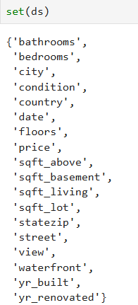
- Data Types and Info:
Using ds.info(), we identified the types of each column:
  - Numerical columns: price, sqft_living, bedrooms, etc.
  - Categorical columns: city, statezip, country, etc.
  - Date/Time column: date
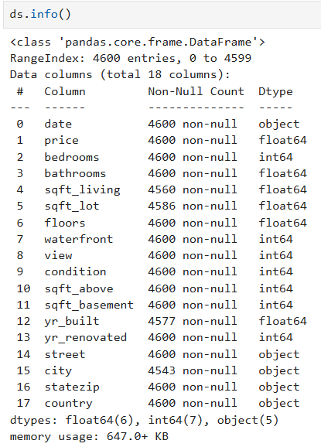
- Statistical Summary:
The ds.describe() function provided a summary of numerical features:
  - Price ranges widely with a large standard deviation, indicating variation in property values.
  - Variables like sqft_living, bathrooms, and bedrooms also show diverse distributions.
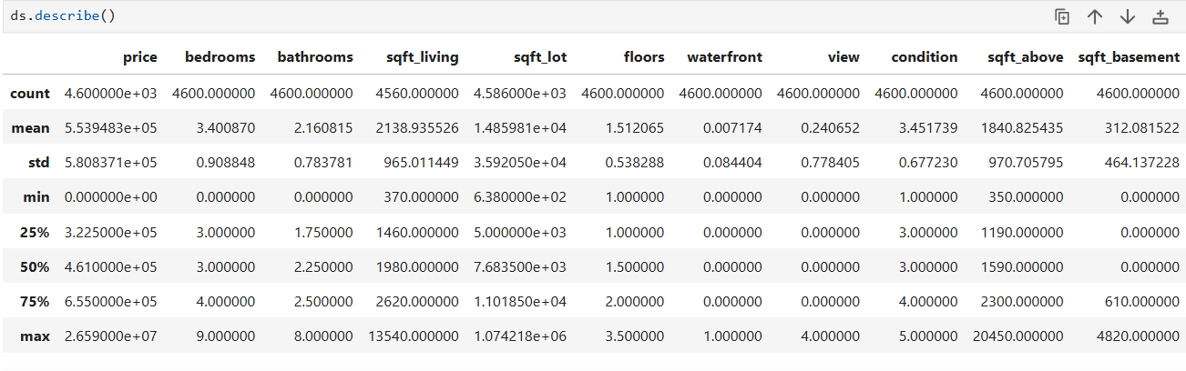

- Missing Values:
We checked for missing values using ds.isnull().sum(). Some columns had null values that required handling during the data cleaning stage to ensure a complete and consistent dataset.
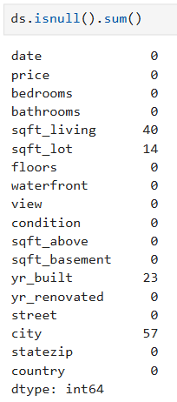

6. Data Cleaning
To ensure accurate analysis and reliable insights, data cleaning was a crucial initial step. The following actions were performed:
- Handling Missing Values:
We identified missing values in the dataset using .isnull().sum() and addressed them appropriately. Depending on the nature and amount of missing data, we either used imputation techniques (e.g., filling with median or mode) or removed rows with excessive null values to maintain data completeness.
BEFORE | AFTER
 | 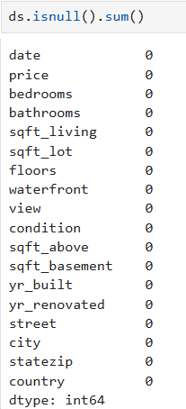

- Addressing Inconsistencies:
We checked for anomalies such as negative values in numerical columns, unrealistic entries and inconsistent formats. These were corrected or removed to ensure data accuracy and uniformity.
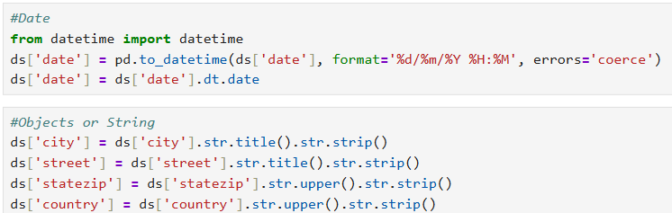

- Handling Categorical Variables:
Categorical variables such as city, statezip, and country were encoded using techniques like label encoding or one-hot encoding as required. This allowed these features to be used effectively in analysis and modeling.

7. Obtaining Derived Metrics
To enhance the dataset and gain deeper insights, several new features were engineered from the existing data. These derived metrics help capture more granular information and improve the interpretability of the dataset.
Property Age
A new column property_age was created to calculate the age of each house based on the current year.

Years Since Renovation
A column renovated was added to calculate how many years ago the house was renovated. If no renovation occurred (yr_renovated = 0), the value is set to 0.

Price per Square Foot
To normalize house prices with respect to property size, the column price_per_sqft was computed:
ds['price_per_sqft'] = ds['price'] / ds['total_sqft']

Bathroom Breakdown
The bathrooms column was decomposed into more interpretable metrics: - full_bathrooms: Extracts the integer part - bathroom_fraction: Extracts the fractional part - Binary indicators: - quarter_bath (0.25) - half_bath (0.5) - three_quarter_bath (0.75)

Floor Features
The floors column was processed to extract floor-related insights: - full_floor: Total number of full floors - has_attic: A binary indicator showing presence of an attic (non-zero decimal part in floors)
8. Filtering Data for Analysis
To ensure accurate and focused analysis, the dataset was filtered to remove data that could distort results. Properties with very high or very low prices, unusual sizes, or invalid combinations of features were excluded. We also focused on recent transactions to reflect the current market. Areas with very few records were removed, and any properties with missing key details or extreme outliers were filtered out. These steps help keep the data clean, relevant, and reliable for analysis.
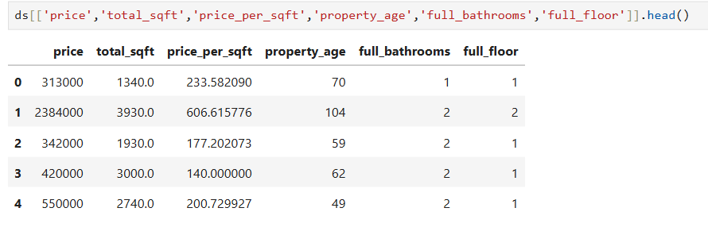
9. Statistical Analysis
Descriptive Analysis
Descriptive statistics were used to understand the overall structure of the dataset. Key statistical measures such as count, mean, standard deviation (std), minimum, 25th percentile (25%), median (50%), 75th percentile (75%), and maximum were calculated for all numerical columns. These values helped identify the average price and size of properties, how much they vary, and the spread of features like bedrooms, bathrooms, and living area. This analysis gave a clear picture of typical property characteristics and highlighted any unusual values or patterns in the data.
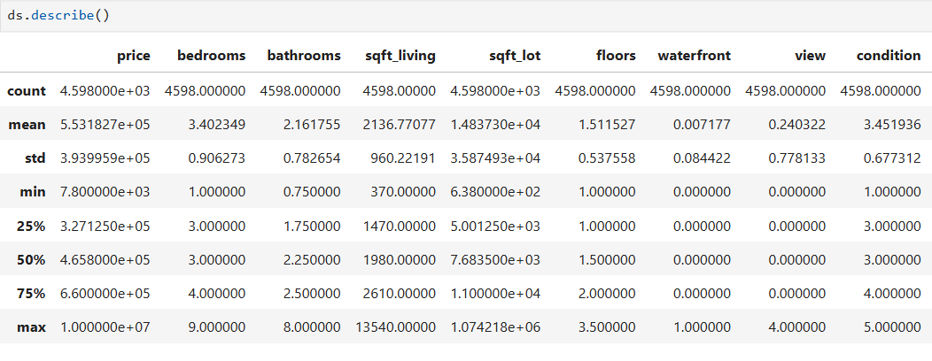

Test Statistics and Hypothesis Testing
To understand the impact of certain features on housing prices, statistical tests were used. A t-test compared the average prices of homes with and without an attic. If the p-value was below 0.05, it showed that attic presence had a significant effect on price. A chi-square test was also done to check if there was a relationship between the view of a house and whether it had an attic. A low p-value here meant there was a meaningful connection between view and attic presence. These tests helped identify which features actually influenced house prices or were linked to each other.
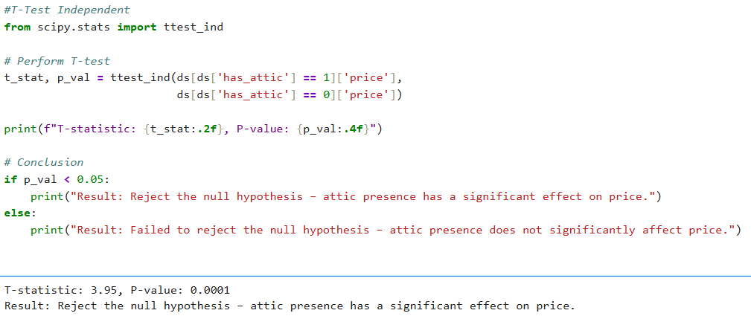
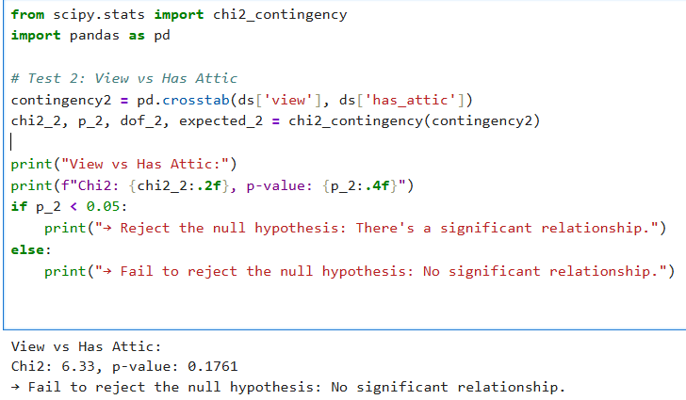

10. Exploratory Data Analysis (EDA) - Univariate Analysis
In univariate analysis, we looked at one feature at a time. We checked price, house size, bedrooms, bathrooms, condition, view, year built, waterfront, and floors. This helped us understand common values and spot any unusual data. We used simple charts like histograms and box plots to show the results.
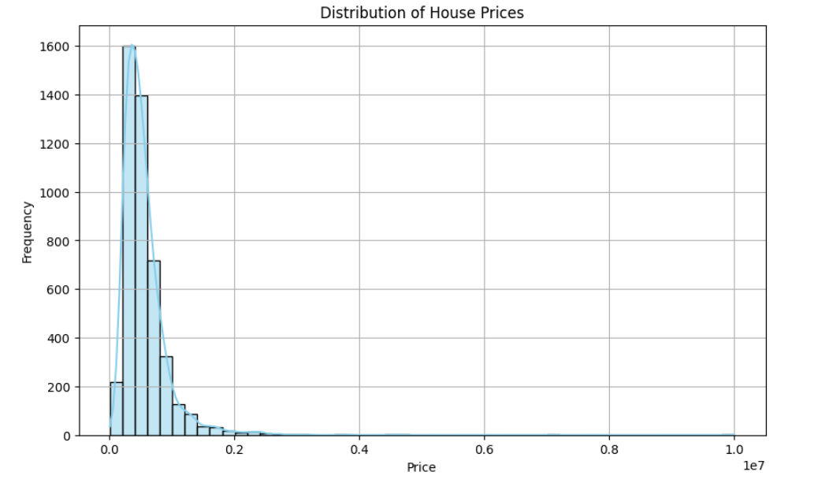
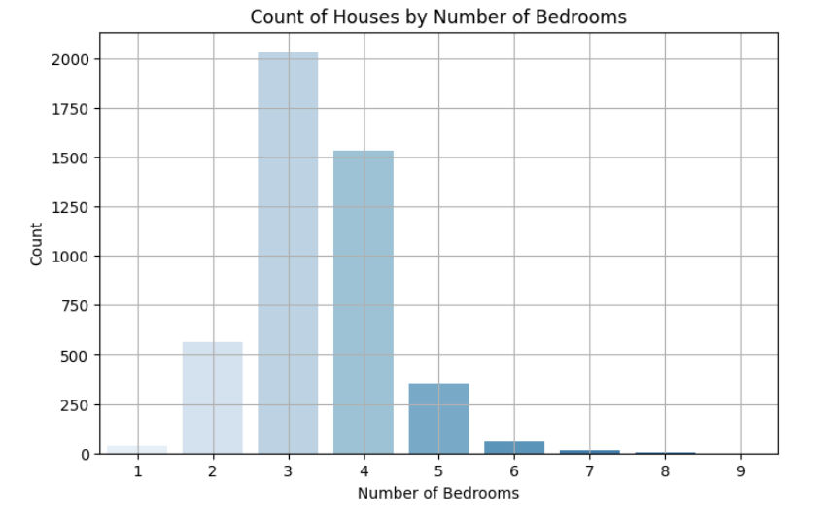

11. Bivariate Analysis
Bivariate analysis helps us understand how two features are related. We checked how price changes with square footage, bedrooms, bathrooms, and lot size to see what affects home value the most. We also compared prices across locations, studied how condition, view, and waterfront relate to price, and looked at how property age and renovation affect value. We used scatter plots, correlation charts, and grouped summaries to clearly show these relationships.

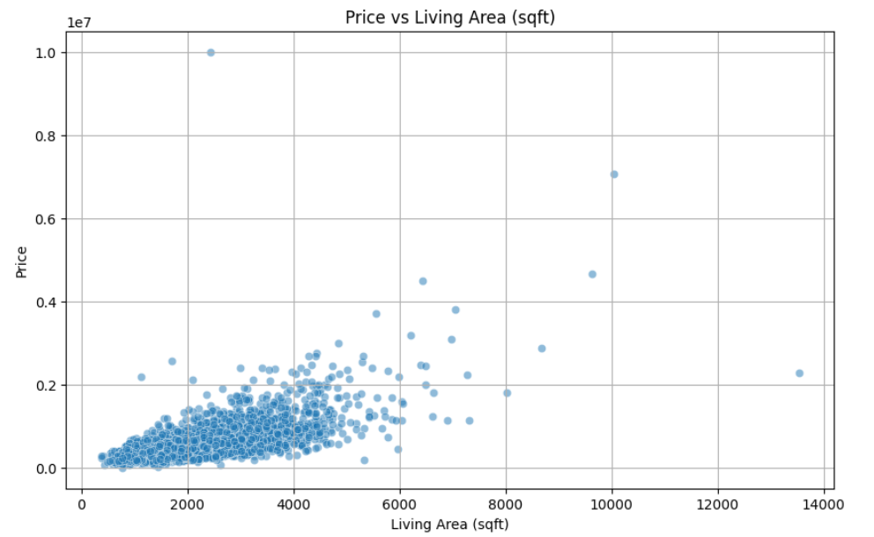
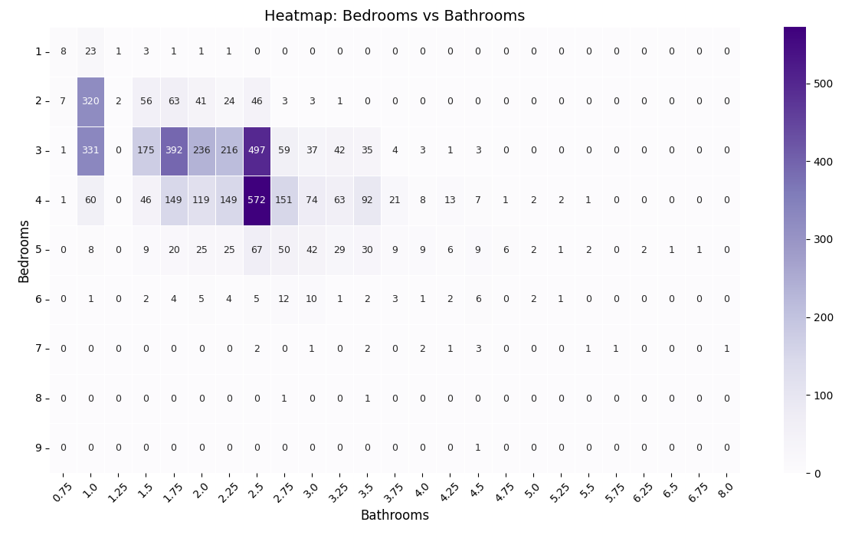

12. Multivariate Analysis
Multivariate analysis looks at how many features together affect house prices. It helps find patterns when multiple things like size, number of rooms, location, and condition are combined. For example, it shows how big houses in good condition in nice areas usually cost more. It can also group similar houses based on these features. This helps us understand which combinations of features are most important in deciding a house’s price.
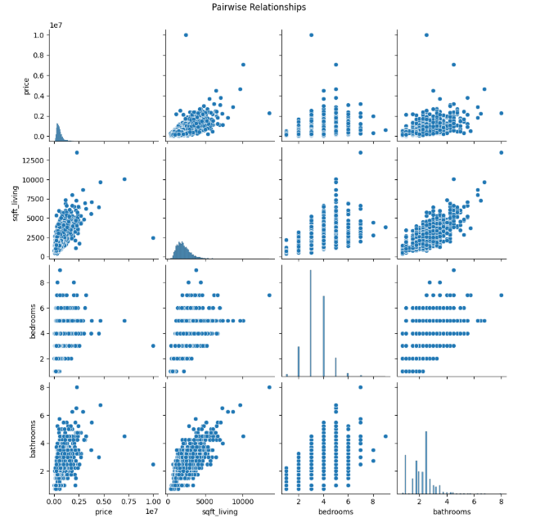
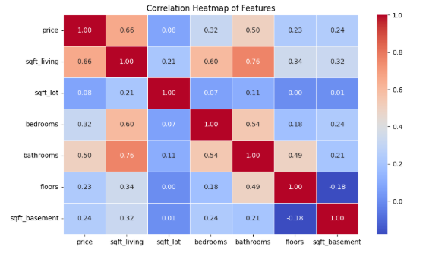
13. Overall Insights from Analysis
- Homes in better condition (4–5) have higher prices.
- Higher view ratings are linked to increased property prices.
- Properties with 3 to 4 bedrooms show the best price-to-size ratio.
- More than 5 bedrooms do not significantly increase the price.
- Larger living area generally leads to higher prices, but with more variation.
- Medina has the highest average property prices, making it the most premium city in the dataset.
- 98039 (Medina area) is the most expensive zip code with the highest average property price.
- Waterfront homes are significantly more expensive than non-waterfront ones.
- Top Configuration: The most frequent type of property is 4 bedrooms with 2.5 bathrooms (572 properties).

Recommendations :
- Target Medina (98039) for premium property development due to its highest average prices.
- Focus on homes with 3–4 bedrooms, as they offer the best price-to-size ratio.
- Build or market waterfront properties, since they command significantly higher prices.
- Maintain or upgrade homes to condition ratings 4 or 5 to boost property value.
- Promote homes with good views, as higher view scores are linked to higher prices.
14. Conclusion
This analysis turned housing data into useful insights, helping us understand what affects property prices. Key factors like location, size, and quality features were found to impact value the most. The study also highlighted different market segments with unique traits. These insights can guide better pricing, investment, and planning decisions. Going forward, building predictive models and including more time-based trends can improve future analysis and decision-making.

